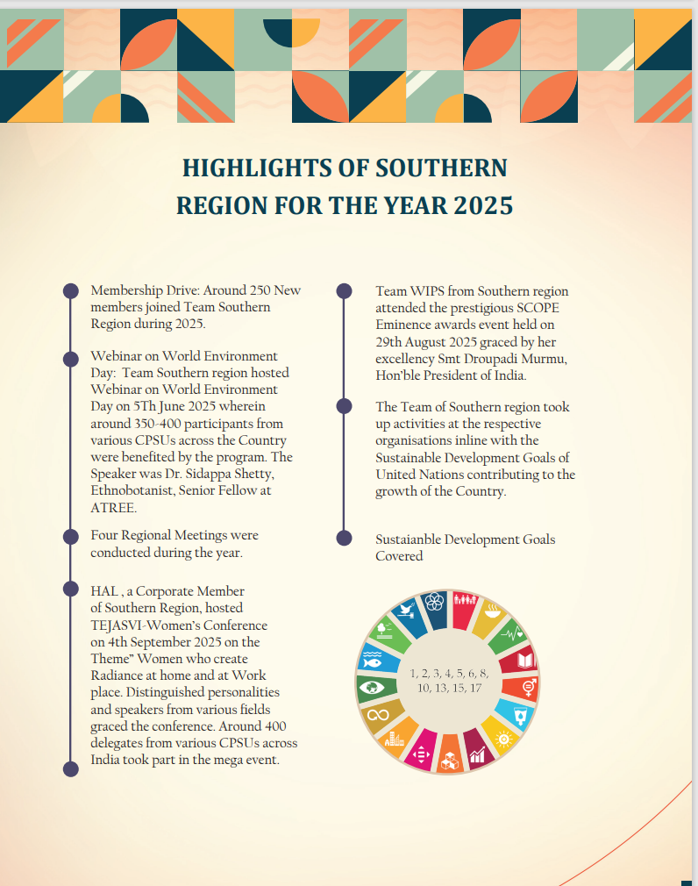

WIPS Members from various PSUS of Southern Region namely Bharath Earth Movers Ltd, Rastriya Ispat Nigam Ltd, Neyveli Lignite Corporation ,Bharath Heavy Electricals Ltd, Chennai Petroleum Corporation Ltd, Madras Fertilizers Ltd, Hindustan Aeronautics Limited , Mangalore Refinery and Petrochemicals Ltd, Indian Oil Corp Ltd etc., took up various activities towards inclusive growth, social responsibility, and community development of Women and Children. The meaningful initiatives reflects the commitment of WIPS members to fostering empowerment, awareness, collaboration, compassion and also the strength of women working together in harmony, unity, commitment and sincere dedication.
Around 91 Initative programs pertaining to Women Health and Wellness: 19 programs, Education and Well being of Children: 11 programs, Women Empowerment: 27 programs, Environment Conservation: 2 programs, Financial Stability : 1 Program , 31 Organisational Initiatives and Collaborative programs were taken up during 2025 which were inline with the sustainable development goals of UN and also mission and objectives of the Forum
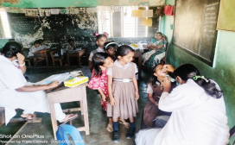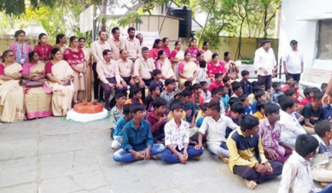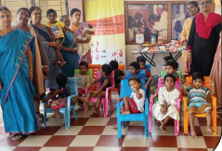
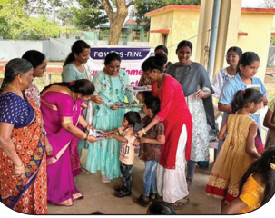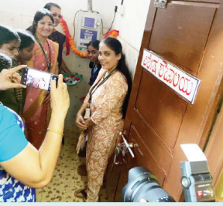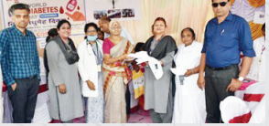
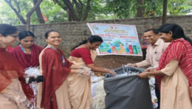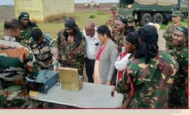
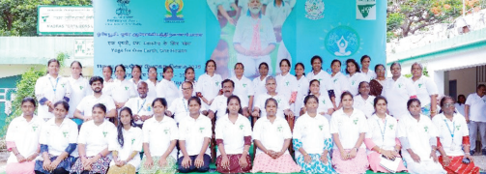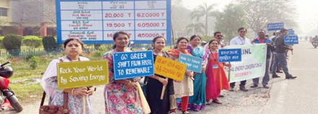

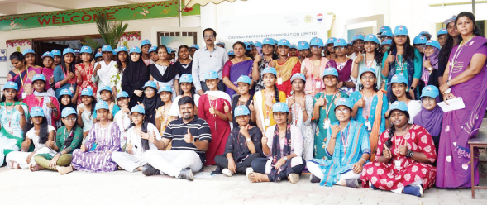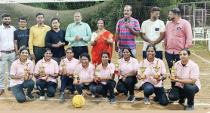
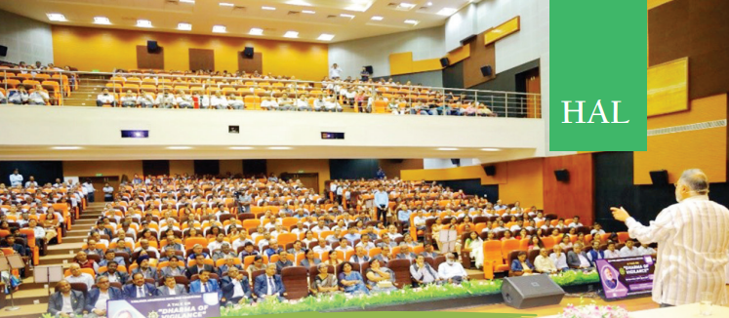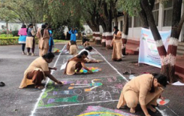
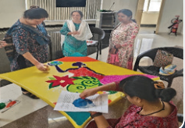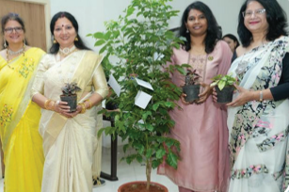

SOUTHERN REGION ELECTIONS, REGIONAL AND CGB MEETINGS
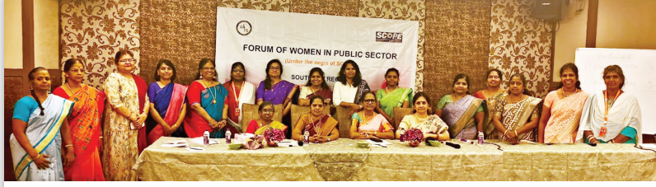
The Southern regional elections to elect Regional Executive Body was conducted on 29th March 2025 at E- Hotel Chennai in the presence of Election Officers Smt. Vijayakumari and Smt. Athilakshmi past Executive members of the region and President WIPS- APEX Smt. Asha Ramamurthy.
The first Regional Meet of Southern region was held on 29th March 2025 at E- Hotel Chennai. Around Twenty five delegates from PSUs across Southern region graced the meet with active participation. The Second and Fourth REB meetings were held on virtual mode on 31st May 2025 and 1st January 2025 on Virtual mode. The Third REB meeting was held on 3rd September 2025 at HAL Management Academy Bangalore. Around Ten delegates from the Southern region attended the meeting.

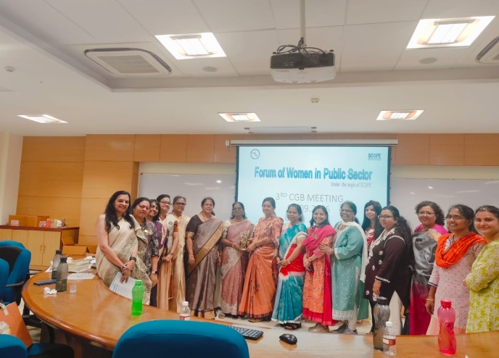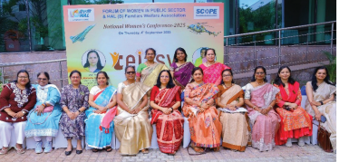

The “3rd Central Governing Body Meet-2025” of WIPS was held on Thursday, 4th September 2025 at HAL Management Academy. Around 20 delegates from the member organisations of all the regions attended the meet. Ms. Asha Ramamurthy President WIPS-APEX along with other APEX members addressed the meeting. Ms. Kavitha Sharma Sr. AGM-BEL, Past Treasurer of WIPS-APEX and Ms Varsha Raut DGM(Aviation)-IOCL and Past president WIPS-Apex were felicitated during the meeting.
MEMBERSHIP DRIVE 2025
Southern Region effectively carried out Membership drive during the year 2025. Around 275 New members were inducted as New WIPS Members. The highlight of membership drive was from Beml under the leadership of Ms Neena Singh GM-HR , around 192 members from the units of Mysore, Bangalore, KGF, Pallakad joined the region. 65 New members joined from BDL, 8 from CPCL and 6 from HAL.
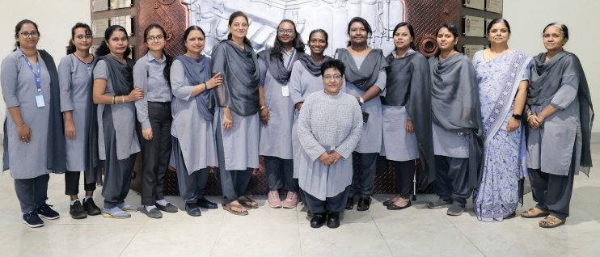
WEBINAR ON WORLD ENVIRONMENT DAY
Southern Region organised a Webinar to commemorate the World Environment Day on 5th June 2025. CPSUs across the country participated in the Webinar. Around 400 employees and officers took part in the event. Speaker Dr Sidappa Shetty, Ethnobotanist, Senior Fellow at ATREE, shared insights about the importance of environmental conservation, while Ms Kalyani Sethuraman, IRAS, Chief Vigilance Officer, spoke about limiting the usage of plastic for a sustainable future. Ms Asha Ramamurthy President WIPS APEX addressed the participants
